PRACTICAL-9

Running sequence:

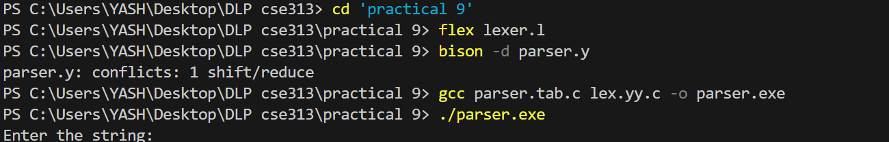

Test cases:

